Aim:
To Implementation and Time analysis of Selection sort
Algorithm:
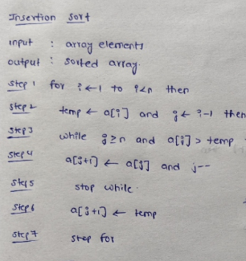

Code:

#include <iostream>
using namespace std;

int main() {
int n;

cout << "Enter the number of elements: ";
cin >> n;

int arr[n];

cout << "Enter " << n << " elements: ";
for (int i = 0; i < n; i++) {
cin >> arr[i];
}
for (int i = 1; i < n; i++) {
int key = arr[i];
int j = i - 1;
while (j >= 0 && arr[j] > key) {
arr[j + 1] = arr[j];
j--;
}
arr[j + 1] = key;
}
cout << "Sorted array: ";
for (int i = 0; i < n; i++) {
cout << arr[i] << " ";
}
return 0;
}

Algorithm:
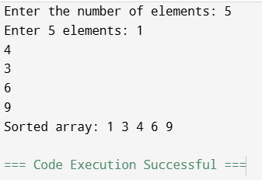

Time complexity:
